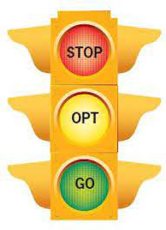

STOP before you act.

Think of all your OPTions and how they will work out.

GO with the best option.

Solution finder