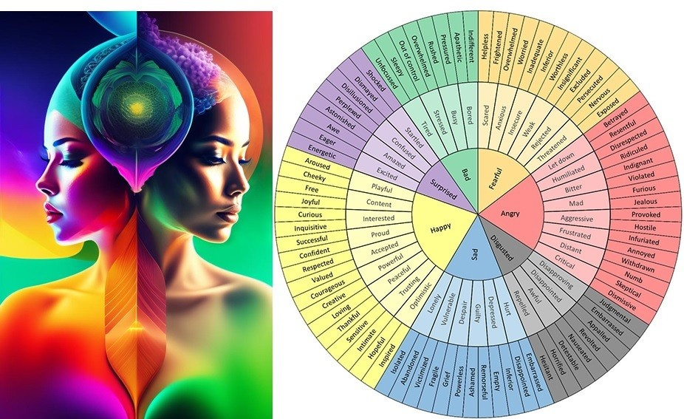

Name the emotion – it is so important when supporting our children’s emotional development that we name their feeling and use as wide a range of vocabulary as possible, that way they adding more into their ‘toolbox’ to help express how they are feeling. Get the whole family involved!