**Brooklands Primary School**

*Uniform policy*

It is our policy that all children wear uniform when attending school. School uniform is part of our ethos and in sending children to Brooklands Primary School, parents agree to support our policy.

**Our policy on school uniform is based on the notion that school uniform:**

* Promotes a sense of pride in the school;
* Creates a sense of community and belonging towards the school;
* Identifies the children with the school;
* Is practical, comfortable and smart;
* Is inclusive for all pupils;
* Is cost effective for parents;

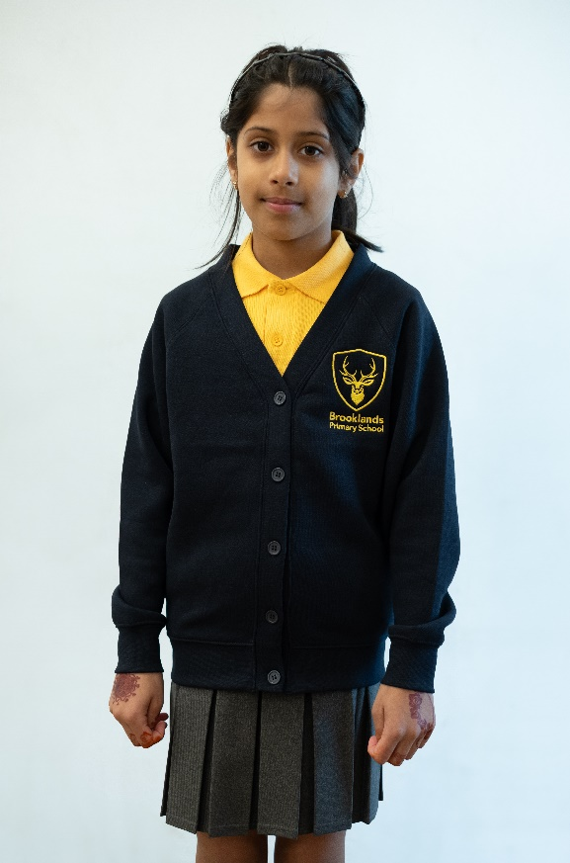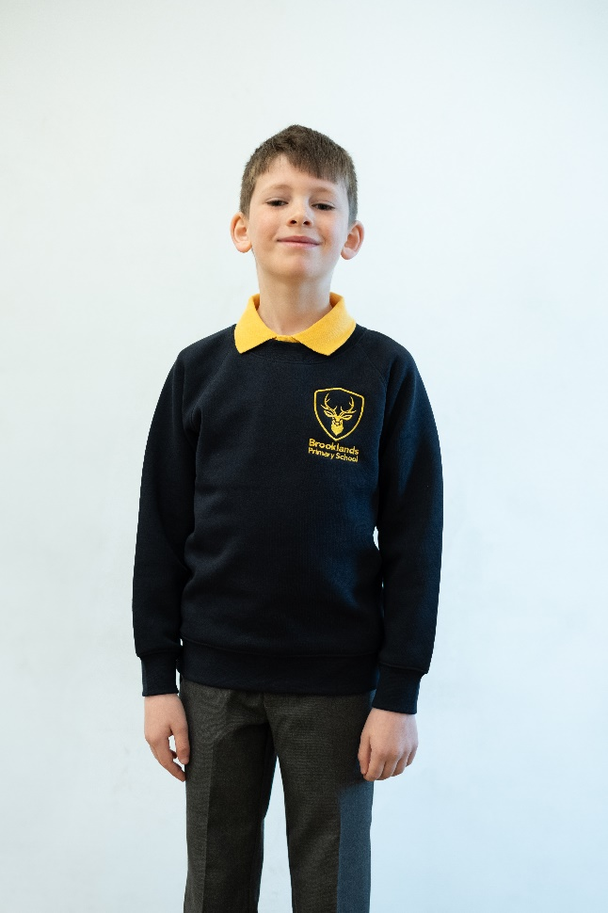**Our uniform consists of (from 1st Sept ‘25 – gradual implementation until 1st Sept ’27):**

**Gold** polo-shirt (not yellow) – we accept a range of gold colours exist; please try where possible to colour-match to ‘deep’ instead of ‘yellow’ gold.

Long-sleeved option acceptable

* Grey trousers, skirt, shorts, pinafore (or current yellow/white summer dress with white socks)
* Grey socks (long or short) or grey tights
* Black (unbranded) shoes or trainers (no coloured designs, laces, soles, boots or open footwear)
* Shoulder length or longer hair must be tied up (bows/bands/clips must be subtle)
* No make-up (including nail varnish) or jewellery (other than studs)
* PE Kit: NAVY, UNBRANDED, PLAIN (ALL ITEMS), WITH BLACK PLAIN TRAINERS

Navy branded sweatshirt (£13.95) or cardigan (£14.95) from [Petites Modes](https://www.petitesmodessale.com/) (compared to £20.95/£21.95 previously). Available after Easter ‘25. Washing instructions: *Wash at 40 degrees. Do not bleach. Tumble dry on a low heat setting. Iron on a cool setting. Do not dry clean*

Only branded item we request. Please reach out if you are struggling to afford this.

* Plain and discreet headscarves
* An appropriately warm coat with a hood
* A peaked cap/hat for summer protection (no sunglasses)
* Swimming: dark/plain swimming costume/trunks/sensible shorts (mid-thigh length), towel, swimming hat. Please note the swimming pool do not permit goggles without a medical note

**Bags**

School bags should be sensible in terms of size, colour and design. Excessively large bags are unhelpful for storage purposes and pupils should only bring to school what they need to support their learning. Stationery is provided at school. Games, toys, cards and valuable items should not be brought to school and are not the responsibility of the school if damaged/lost.

**Please label all school clothes with your child’s name.** We do our best to re-unite children with clothes they leave lying around the playground and building.

**Please ensure your child is aware of and adheres to our school uniform policy. We thank you for your cooperation in implementing this policy.**

**Pre-loved uniform:** Our PTA regularly arrange pre-loved uniform sales. Please contact the school office if you have any questions about uniform.

**Uniform Supplier:**   
School uniform with Brooklands logo is available from: [Petite Modes](https://www.petitesmodessale.com/), 9 Tatton Rd, Sale, M33 7EB, 01619734231 although this is not mandatory.

Please note we do not stock/sell uniform in school.