**CLASSES FROM SEPTEMBER 2025**

Please find below a list of new classes from September 2025

|  |  |
| --- | --- |
| **HEADTEACHER: Mr Beith** | |
| **DEPUTY HEADTEACHER: Mr Shrimpling** | |
| **BUSINESS MANAGER: Mrs Miskelly** | **ASSISTANT HEADTEACHERS: Mrs Hampton, Mrs Simpson** |
| **NURSERY from September**  Nursery taught by Mrs Humphrey MTW & Mrs Pickthall ThF (Led by Mrs Hampton)  *PPA cover: Mrs Istanbul (Tues pm)* | **YEAR 3 from September**  New classes will become:   * 3W: Miss Williams (Lead) * 3A: Miss Axon * 3P: Mrs Poole   *PPA cover: Mrs Istanbul (Mon am), Mrs Dorward (Weds am) & Mrs Duras (Mon pm)*  *PE days for Sept: 3W – Mon/Thurs; 3A – Mon/Weds; 3P – Tues/Thurs* |
| **RECEPTION from September**  New intake taught in the following classes:   * RHW: Mrs Hampton (Lead) – MTW & Mrs Walton - ThF * RC: Mrs Cunningham * RT: Mr Clark   *PPA cover: Mrs Istanbul (Mon pm, Tues am)*  *PE days for Sept: Friday for all pupils* | **YEAR 4 from September**   * 3W will become 4R: Mrs Rodger (Lead) * 3A will become 4A: Mr Alecock * 3P will become 4SD: Miss Shaw MTWTh & Mrs Dorward F   *PPA cover: Mrs Dorward (Thurs am/pm)*  *PE days for Sept: 4R – Tues/Fri; 4A – Mon/Tues; 4SD – Tues/Fri*  *(swimming takes place on a Monday morning on rotation)* |
| **YEAR 1 from September**   * RC will become 1S: Miss Woodworth (Lead) * RW will become 1N: Miss Neal * RH will become 1W: Miss Wood   *PPA cover: Mrs Gillan (Mon am/pm, Tues am)*  *PE days for Sept: 1S – Tues/Weds; 1N – Tues/Fri; 1W – Weds/Fri* | **YEAR 5 from September**   * 4A will become 5L: Mrs Lythgoe née Sanderson (Lead) * 4O will become 5S: Mrs Sweeney * 4D will become 5W: Miss Ward   *PPA cover: Sports And All (PE – Mon pm, Weds pm, Thurs pm)*  *PE days for Sept: 5L – Mon; 5S – Thurs; 5W – Weds (double sessions)* |
| **YEAR 2 from September**   * 1W will become 2B: Mrs Burns (Lead) * 1N will become 2O: Miss O’Brien * 1S will become 2W: Miss Warburton   *PPA cover: Mrs Gillan (Weds am/Weds pm) & Mrs Hampton (Thurs pm)*  *PE days for Sept: 2B – Weds/Thurs; 2O – Mon/Thurs; 2W – Mon/Weds* | **YEAR 6 from September**   * 5S will become 6S: Mrs Simpson (Lead) & Mrs Adams (Apprentice Teacher) * 5C will become 6D: Mrs Darlaston * 5SD will become 6O: Mrs Dobinson   *PPA Cover: Mrs Simpson (Mon)*  *PE days for Sept: 6S – Weds; 6D – Thurs; 6O – Fri (double sessions)* |

Children have spent the afternoon meeting their new teacher in their new classrooms and will no doubt come home excited to talk about it! We look forward to seeing you this evening from 3:40pm – 6pm where you will be able to meet your child’s new teacher.

We say a big thank you and good luck to Miss Robinson who is leaving us to pursue a SENDCo role at Loreto Grammar School after 5 years at Brooklands. We also thank Miss Chilvers who is relocating to Australia and say bon voyage to Miss Cooper who is taking a 12 months sabbatical. We also welcome back Miss Shaw and Mrs Jones (who will continue as SENDCo alongside Mrs Fletcher) from maternity leave. We welcome Mrs Rodger to the school who was the successful candidate following a very competitive Year Group Lead recruitment process, and brings significant experience and expertise to the school.

We look forward to seeing you this evening.

Yours sincerely

Mr Beith

**MAP FOR DROP OFF/COLLECTION 25-26 AND OPEN EVENING 25TH JUNE**

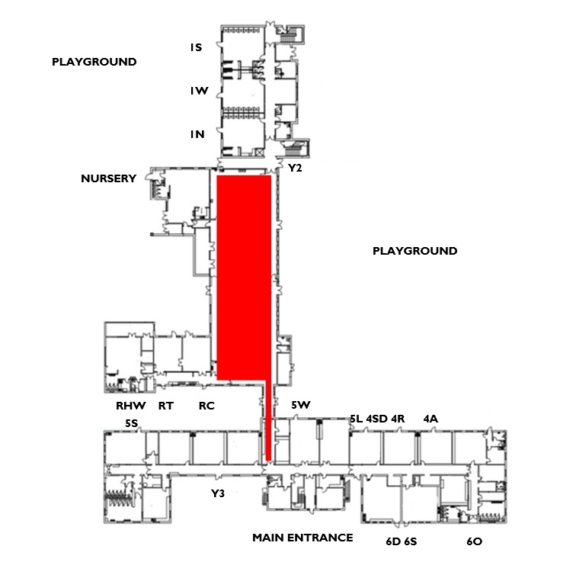

**Y2**